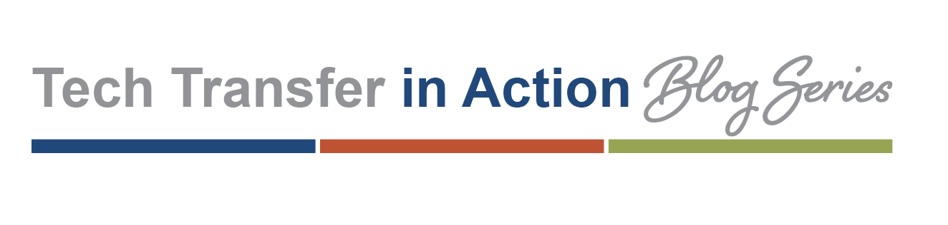
Vision:
To create a semi-monthly blog series called Tech Transfer in Action that will feature the work of the ATTC Regional Centers. The goal of this series will be to increase visibility of the Centers’ projects, with a specific focus on the implementation aspect of the Technology Transfer Model.

Objective:
Each Center will be asked to submit two blog articles annually to promote their work, highlight impactful projects and share knowledge. Tech Transfer in Action will be housed on the ATTC / NIATx Service Improvement Blog.

Specifications:
The blog series will launch in January 2020. Blogs will be published the first and third Wednesdays of the month. Deadlines will be the first business day of the preceding month (e.g., a blog published on January 15 would be due December 1). The National Hispanic and Latino ATTC will be featured in October and the National American Indian and Alaska Native ATTC will be featured in November — to coincide with respective national heritage months. Please see the publication calendar on page 2 for further details.

Word count: 500-750 words

Images (encouraged, but optional): At least 150 dpi. Assure photo release forms have been signed for anyone featured in photos

Centers will be asked to address at least one of the following bullet points in their blog articles:

- Connected learning series and communities
- Organizational development and systems change projects
- Technical assistance to organizations, localities, and states

Including qualitative data and comments / feedback from end-users should also be considered when writing articles.

Do you need help composing your blog article? The ATTC NCO can help! Feel free to contact us with this easy-to-use request portal: https://ttcrequest.zendesk.com.

Publication Calendar:

Submission deadline | Publish Date | Region
December 2, 2019 | January 2, 2020 | Region 1 (New England ATTC)
December 2, 2019 | January 15, 2020 | Region 10 (Northwest ATTC)
January 3, 2020 | February 5, 2020 | Region 2 (Northeast & Caribbean ATTC)
January 3, 2020 | February 19, 2020 | Region 9 (Pacific Southwest ATTC)
February 3, 2020 | March 4, 2020 | Region 3 (Central East ATTC)
February 3, 2020 | March 18, 2020 | Region 8 (Mountain Plains ATTC)
March 2, 2020 | April 8, 2020 | National American Indian and Alaska Native ATTC
March 2, 2020 | April 22, 2020 | Region 4 (Southeast ATTC)
April 1, 2020 | May 6, 2020 | Region 7 (Mid-America ATTC)
April 1, 2020 | May 20, 2020 | Region 5 (Great Lakes ATTC)
May 1, 2020 | June 3, 2020 | National Hispanic and Latino ATTC
May 1, 2020 | June 17, 2020 | Region 6 (South Southwest ATTC)
June 1, 2020 | July 1, 2020 | Region 1 (New England ATTC)
June 1, 2020 | July 15, 2020 | Region 10 (Northwest ATTC)
July 1, 2020 | August 5, 2020 | Region 2 (Northeast & Caribbean ATTC)
July 1, 2020 | August 19, 2020 | Region 9 (Pacific Southwest ATTC)
August 3, 2020 | September 2, 2020 | Region 3 (Central East ATTC)
August 3, 2020 | September 16, 2020 | Region 8 (Mountain Plains ATTC)
September 1, 2020 | October 7, 2020 | Region 4 (Southeast ATTC)
September 1, 2020 | October 21, 2020 | National Hispanic and Latino ATTC
October 1, 2020 | November 4 | Region 6 (South Southwest ATTC)
October 1, 2020 | November 18 | National American Indian and Alaska Native ATTC
November 2, 2020 | December 2 | Region 5 (Great Lakes ATTC)
November 2, 2020 | December 16 | Region 7 (Mid-America ATTC)

