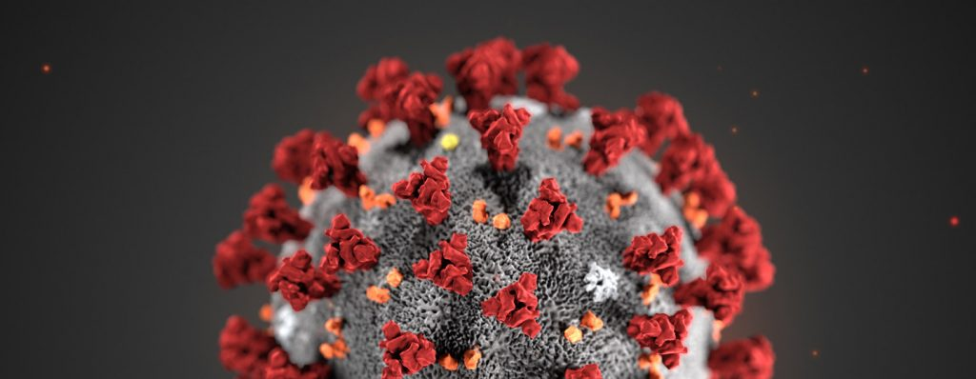

ACF Native American COVID-19 RESOURCES

The Administration for Children and Families (ACF) is a division of the U.S. Department of Health and Human Services (HHS). ACF promotes the economic and social well-being of children, families, individuals, and communities with leadership and resources for compassionate, effective delivery of human services. The Agency supports critical programs that are important for tribes and Native American communities as they respond to the Coronavirus Disease 2019 (COVID-19). Examples of ACF programs include: Head Start and Early Head Start, Temporary Assistance for Needy Families (TANF), child welfare, Low Income Home Energy Assistance Program (LIHEAP), and Social and Economic Development Strategies (SEDS).

ACF encourages people involved in Agency programs and those who work in the human service enterprise to follow the President’s Coronavirus Guidelines for America, 30 Days to Slow the Spread.
The Guidelines advise Americans to listen to and follow the directions of state and local authorities.

OFFICE OF MANAGEMENT AND BUDGET (OMB) AND ACF GRANT FLEXIBILITIES RELATED TO COVID-19

- OMB Memo 3-20-17 – Administrative Relief for Recipients and Applicants of Federal Financial Assistance Directly Impacted by the Novel Coronavirus (COVID-19) due to Loss of Operations
- ACF Information Memorandum: ACF grant flexibilities in conducting human service activities related to or affected by COVID-19
- Using Federal TANF and State MOE Funds for Families in Areas Covered by a Federal or State Disaster Declaration: While OFA does not have general authority to waive TANF requirements or penalties, the HHS Secretary may not impose a penalty on a tribe operating an approved Tribal TANF program if a natural disaster’s disruptive impact was so significant as to cause the tribe’s failure to meet the requirement.

ACF PROGRAM OFFICE INFORMATION FOR NATIVE AMERICAN COMMUNITIES

On March 27, 2020, the President signed the Coronavirus Aid, Relief, and Economic Security (CARES) Act. This includes $6.3 billion in additional funding for ACF to respond to coronavirus related needs. A summary of the ACF provisions can be found here.

- Administration for Native Americans (ANA): ANA is receiving requests from Native American grantees seeking flexibility in carrying out their projects in response to COVID-19. The primary requests include: (1) grant modifications in response to tribal and state declarations, including school closings, social distancing requirements, telework flexibilities, and continued compensation for project staff; and (2) requests for no-cost extensions and/or extension of deadlines for submitting reports. Other issues include impacts from loss of program income. ANA grantees are encouraged to review the flexibilities for administrative, financial management, and audit requirement relief issued by ACF on March 30, 2020, which can be found here.

- Low Income Home Energy Assistance Program (LIHEAP): There are no changes to the federal LIHEAP law in light of COVID-19. As a block grant program, LIHEAP grantees normally have flexibilities in how they can change or revise their programs throughout the year to address changing needs in their communities. Each tribal grantee must decide what is appropriate for their own community. Tribal LIHEAP grantees also have broad flexibility in deciding what kinds of LIHEAP assistance to offer and how to vary the amount of assistance/benefits for each household. During emergencies, LIHEAP grantees may consider increasing the amount of benefits, or providing supplement benefit payments to households that have already received one LIHEAP benefit this year. Tribal grantees should contact their Office of Community Services LIHEAP Program Specialist for guidance. The LIHEAP Initial COVID-19 Program Guidance can be found here.

- Office of Child Care:
- Child Care Development Fund: Lead Agencies have the flexibility to change certain eligibility or priority criteria to permit uninterrupted child care, to define income, and to set the income threshold for purposes of Child Care and Development Fund (CCDF) eligibility; the option to waive family co-payment requirements for families that meet criteria established by the Lead Agency—which may include, for example, families impacted by federal or state declared emergency situations; and the option in some cases to use quality dollars to provide immediate assistance to impacted families, including families that do not participate in CCDF. Requirements differ across tribal CCDF grantees depending on size, so not all flexibilities are equally relevant to all.

- Tribal Maternal, Infant, and Early Childhood Home Visiting (MIECHV): ACF recognizes the important supports that tribal home visitors can provide to families during this difficult time, including parenting supports, help connecting to resources, and social support for those who are isolated. Tribal MIECHV grantees have the flexibility to provide home visits virtually (either by video conference or by phone), in accordance with home visiting model developer guidance. Grantees also have the flexibility to have their staff work remotely rather than in the office.

- Children’s Bureau: The Children’s Bureau issued a letter to Child Welfare Leaders on March 18, 2020 that addresses: (1) requirements for case worker visits to children in foster care; (2) Program Improvement Plans developed to address the results of a Child and Family Services Review; (3) the onsite Title IV-E Eligibility Review; (4) child abuse and neglect investigations; and (5) other legislative and regulatory flexibility requirements. The letter to Child Welfare Leaders is available here. Additional information and resources for state and tribal child welfare professionals relating to COVID-19 are available here.

- Office of Family Assistance (OFA): OFA released a Program Instruction (PI) to State and territorial Agencies and Tribal Agencies administering the Temporary Assistance for Needy Families (TANF) Program on March 24, 2020. The PI addresses TANF’s administrative flexibilities for states and tribes and includes questions and answers about how state and tribal grantees might use TANF to address COVID-19. The OFA PI is available here.

- Office of Head Start (OHS): OHS has directed programs to continue to pay wages and provide benefits for staff unable to report to work during center closures necessary to address COVID-19. This flexibility remains in effect through April 30, 2020, unless further extended by OHS. During center closures, employees should continue to engage families and to deliver services to the extent possible, remotely. Head Start and Early Head Start programs may provide meals and snacks to children during center closures. Communications regarding OHS coronavirus prevention and response are available here.

- Family Violence Prevention and Services Act (FVPSA): The FVPSA program recognizes the need for funding flexibilities and continuity of operations for all domestic violence shelters, state domestic violence coalitions and tribes, including the national domestic violence hotline and the StrongHearts Native Helpline. FVPSA anticipates issuing program guidance to domestic violence programs regarding COVID-19. Guidance will include questions and answers regarding flexibilities for FVPSA-funded programs. FVPSA is mandated to allocate 10% of its appropriation to Tribes and Tribal organizations. For FY 2018 and 2019, Congress increased the appropriations to supplement existing funding for American Indian/Alaskan Native Tribes. For FY 2019, the total amount of funding provided was $20,170,060 funding 252 tribes and tribal organizations.

- Family and Youth Services Bureau (FYSB) – National Runaway Safeline (NRS): NRS is a FYSB funded project to provide a communication system for runaway and homeless youth and their families. NRS will continue to provide crisis intervention services, support and access to local resources to youth ages 12 to 21 and their families through their hotline, 1-800-RUNAWAY (786-2929) and live chat, emails and forums at 1800RUNAWAY.org.

ABOUT COVID-19

- The Centers for Disease Control and Prevention (CDC) provides information on the symptoms of COVID-19 and the emergency warning signs for seeking medical attention. CDC also provides specific guidance for:

    - Older adults
    - Pregnant women
    - Schools and childcare programs
    - First responders and law enforcement
    - Resources for your home
    - Community- and Faith-Based Leaders
    - Business and employers
    - Anxiety and stress

Other federal and national tribal COVID-19 resources include:

  - Coronavirus (COVID-19)
  - Government Response to Coronavirus, COVID-19
  - Indian Health Service (IHS)
  - Bureau of Indian Affairs (BIA)
  - Substance Abuse and Mental Health Services Administration (SAMHSA)—Talking with Children: Tips for Caregivers, Parents, and Teachers During Infectious Disease Outbreaks
  - Federal Emergency Management Agency (FEMA)
- National Runaway Safeline (NRS)
  - National Indian Health Board (NIHB)
  - National Congress of American Indians (NCAI)
  - National Indian Education Association (NIEA)
  - Center for American Indian Health

