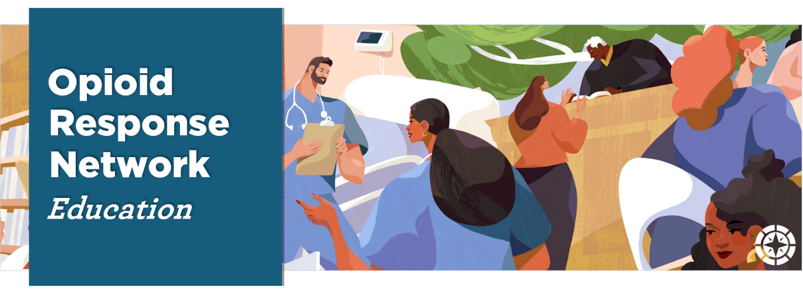

Providing Peer Based Recovery Support Services for Pregnant and Parenting Families two-day virtual training AND two-day Training of Trainers Announcement

Driven by the opioid epidemic, the United States has seen an expanded focus on the treatment of substance use disorders and as a result an expanded interest and investment in recovery support services. To support this growing demand, the Opioid Response Network (ORN) is hosting a two-day, virtual training: Providing Peer Based Recovery Support Services for Pregnant and Parenting Families. In addition, ORN will host a two-day Training of Trainers to build national capacity around this important topic. Please read the content below to determine whether this training is a fit for you/your organization and for details regarding the eligibility and application process for the Training of Trainers.

Providing Peer Based Recovery Support Services for Pregnant and Parenting Families two-day virtual training: The overall goal of this training is to better prepare Peer Recovery Support Specialists to meet the diverse needs of pregnant and parenting families in early recovery.

Training Topics Include:

- Understanding the mechanisms that support a secure attachment for young children
- Strategies that support and strengthen parent-child relationships
- Fostering and strengthening nurturing parent/child relationships within the context of peer support services
- Working in diverse settings such as health care or child welfare
- Working in coordination with other community providers serving families with young children
- Working with individuals and families through pregnancy, delivery, and parenting babies with NAS/NOWs
- Recovery-oriented and person-centered planning that is designed to support the growth of Recovery Capital

Recovery and parenting both occur in the context of relationships. This training is designed to help participants build skills to support/strengthen families as they grow and develop in their roles as nurturing parents.

Training Dates/Times

Day 1 (Training): Monday, July 12, 2021  - 10:00 am - 5:30 pm Eastern  - 9:00 am - 4:30 pm Central  - 8:00 am - 3:30 pm Mountain  - 7:00 am - 2:30 pm Pacific | Day 2 (Training): Tuesday, July 13, 2021  - 10:00 am - 5:30 pm Eastern  - 9:00 am - 4:30 pm Central  - 8:00 am - 3:30 pm Mountain  - 7:00 am - 2:30 pm Pacific

Who Should Attend?
- Those who currently provide peer-based recovery support services to pregnant/parenting families
- Those who are recognized as someone qualified to provide peer support services in their state
- Those providing supervision to peers working with pregnant/parenting families
- Those who work in one or more of the following settings: 1) a substance use disorder treatment service; 2) a recovery care organization (RCO); 3) a child welfare or home visiting program; 4) a healthcare or emergency crisis service

Learning Objectives
- Be able to list and describe 2-3 practices at their organization that they plan to change or adjust in result of what they learned from the training surrounding assisting clients with pregnancy and parenting family needs.
- Be able to explain their perspectives around how peers can implement positive parenting education and skills in their work with clients.
- Be able to describe two specific strategies to support and strengthen parent/child relationships.

Registration for this training is limited to 30 total participants with priority given to those who are accepted for the Training of Trainers

Registration for the Providing Peer Based Recovery Support Services for Pregnant and Parenting Families two-day virtual training only can be completed at this link: https://forms.gle/xMzg3ZNiH49cr4Q8A (those interested in both the training and ToT please follow the link at the end of this announcement)

Providing Peer Based Recovery Support Services for Pregnant and Parenting Families two-day Training of Trainers

Those interested in participation in the ToT are required to attend the two-day training on
July 12 & 13

What is a Training of Trainers (ToT)?
A ToT connects master trainers with individuals to prepare them to teach the subject matter effectively, lead activities that reinforce learning, and build their capacity to train others. Completing the ToT will provide the knowledge, skills, and training materials needed to facilitate the training Providing Peer Based Recovery Support Services for Pregnant and Parenting Families.

What background and experience should I have to be considered for the ToT?
This training is best facilitated by a multidisciplinary team that includes individuals with expertise in child development, family support, and health promotion specific to pregnancy and early post-partum, AND individuals with expertise in peer substance use disorder recovery support services. As such, applicants will be asked to indicate their area(s) of expertise so they may be paired with another participant to form a training team.

Training of Trainers Training Dates/Times

Day 1 (ToT): Tuesday, July 27, 2021  - 10:00 am - 5:30 pm Eastern  - 9:00 am - 4:30 pm Central  - 8:00 am - 3:30 pm Mountain  - 7:00 am - 2:30 pm Pacific | Day 2 (Training): Wednesday, July 28, 2021  - 10:00 am - 5:30 pm Eastern  - 9:00 am - 4:30 pm Central  - 8:00 am - 3:30 pm Mountain  - 7:00 am - 2:30 pm Pacific

Learning Objectives-ToT:
- Apply current practices in delivering the training Providing Peer Based Recovery Support Services for Pregnant and Parenting Families.
- Use facilitative skills to promote learner engagement, reflective practice, critical thinking, and skill acquisition.
- Show mastery in delivering key training strategies such as, brainstorming, roleplaying, and practice sessions.

Participants’ Roles & Responsibilities
- Full participation in the ToT on both days.
- Given the interactive nature of this training experience, participants must turn on the camera of their smart device or computer camera. ToT participants will be expected to practice the delivery training content and provide feedback to co-participants.

Registration
If you are interested in both the training and the ToT, please follow this link to complete an application by following this link: https://forms.gle/5WpAoiWgd3LQaEhh8.

Questions?
Contact Rachel Witmer at rrwitmer@umkc.edu

Funding for this initiative was made possible (in part) by grant no. 1H79TI083343 from SAMHSA. The views expressed in written conference materials or publications and by speakers and moderators do not necessarily reflect the official policies of the Department of Health and Human Services; nor does mention of trade names, commercial practices, or organizations imply endorsement by the U.S. Government.

