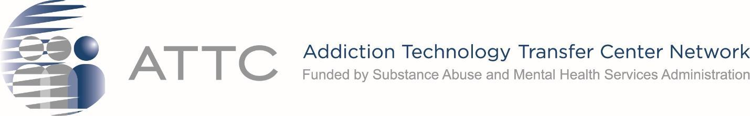

ATTC Directors Meeting, May 26, 2022, 3:00 – 4:15 pm ET
Time  (Eastern Time) | Topic | Speaker/Facilitator
3:00 pm | Welcome  - Please write your name and ATTC in the chat to serve as roll call | - Laurie Krom, Holly Hagle
3:05 pm | SAMHSA Center for Substance Abuse Treatment (CSAT)  - Presentation and Q&A | - Dr. Yngvild Olsen, Dr. Karran Phillips
3:30 pm | SAMHSA, ATTC NCO, and Other Network Updates | - Humberto Carvalho, Twyla Adams  - Laurie Krom  - Sara Becker
3:40pm | Workgroup Updates  - Stimulant  - Dissemination and Implementation  - Building Health Equity and Inclusion  - Update on HEK Course | - Tom Freese, Beth Rutkowski, Jeanne Pulvermacher  - Lisa Carter  - Alfredo Cerrato and Jaye Yarbrough
3:55 pm | Speed Sharing - Summer Time and the Living is Easy - But Usually Not for ATTCs!  What are your ATTC’s summer plans? What ATTC activities are you looking forward to that you want to share? | All
4:05 pm | Summarize Action Items | - Laurie Krom and Holly Hagle
4:15 pm | Adjourn

PLEASE COMPLETE THE GPRA SURVEY: https://ttc-gpra.org/P?s=893627

