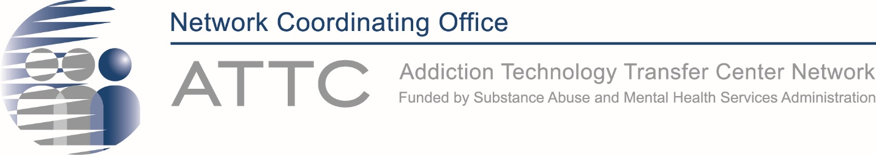
ATTC Network Directors Meeting
Agenda
August 3, 2023
Time (ET) | Item | Lead
3:00 – 3:05 pm | Welcome, Roll Call, Agenda Review | Laurie Krom
3:05 – 3:15 pm | Updates from SAMHSA/CSAT | Twyla Adams
3:15 – 3:25 pm | Network Updates from the NCO  - Please review the list below. Questions or Comments? | Laurie Krom
3:25 – 4:00 pm | Sharing ideas and lessons learned from the Syndemic Solutions Summit and dinner with Dr. Olsen | All ATTC Directors in attendance
4:00 – 4:15 pm | Parking Lot | Laurie Krom
4:15 pm | Adjourn  PLEASE Complete our GPRA Survey (https://ttc-gpra.org/P?s=758281)

Network-wide updates from the NCO:
- CM Task Force – we are working with Ashley Helle to wrap up all documents to package and send to SAMSHA. We hope to wrap up the task force in the upcoming weeks and present to CSAT leadership in the next month or two.
- D&I Workgroup – Subcommittee 1 has already disseminated their infographics, thanks for sharing with the 3 networks. Subcommittee 2 is finalizing their one-pagers to include in a toolkit. The group chose to take a short hiatus for the summer, we will reconvene in-person at AHSR in NY the week of October 18. Any ATTC-ers interested in this workgroup who will be in attendance at AHSR are welcome to attend. Please email Ashley Helle for details.
- Workforce Development Workgroup – the NCO is working with a consultant to support the workgroup in moving forward with the listening sessions they had planned in late Spring. The next meeting is scheduled for August 9th, everyone on the workgroup should have received the invite from Akshat Gandhi. If you have not received the invite, or you would like to be part of the workgroup, please email Maxine Henry.
- BHEI Workgroup – Due to several constraints, the workgroup members have decided not to move forward with the CLAS/NIATx curriculum. Those ATTC who offered to financially support the CLAS/NIATx curriculum development may redirect those funds elsewhere. We will not be using them. Thank you to all of the ATTCs for your support. We continue to meet monthly and are planning our next steps (which may include an update to the CLAS Matters material and a more formal ToT).

