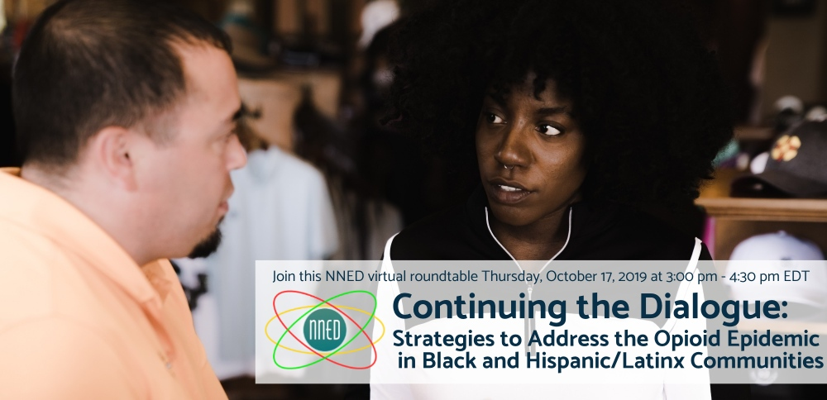
Facebook
What strategies can be used to help move conversations and work to end the opioid crisis? This webinar will take a deeper dive into community-focused, culturally and linguistically-resonant strategies to prevent and treat opioid misuse and addiction in Black and Hispanic/Latinx communities. Join this NNED virtual roundtable on Thursday, October 17 at 3:00 pm – 4:30 pm EDT to find out!
Register now! http://bit.ly/nned-addressing-opioids
Learn more: https://nned.net/5481/

Twitter
How can strategies to end the opioid crisis in Black and Hispanic/Latinx communities be community-focused and culturally and linguistically-resonant? Join the NNED virtual roundtable on October 17th at 3pm EDT. Learn more and register: https://nned.net/5481/

How can we effectively work with community to curb and eliminate the opioid crisis in Black and Hispanic/Latinx groups? Find out in this @nned_net virtual roundtable on Thursday, October 17 at 3pm EDT. Register now: http://bit.ly/nned-addressing-opioids

LinkedIn
Join this NNED virtual roundtable on Thursday, October 17 at 3:00 pm – 4:30 pm EDT, which will build off of SAMHSA’s original webinar (https://wp.me/p3Jgmd-20S), and take a deeper dive into community-focused, culturally and linguistically-resonant strategies to prevent and treat opioid misuse and addiction in Black and Hispanic/Latinx communities.
Register now! http://bit.ly/nned-addressing-opioids
Learn more: https://nned.net/5481/

