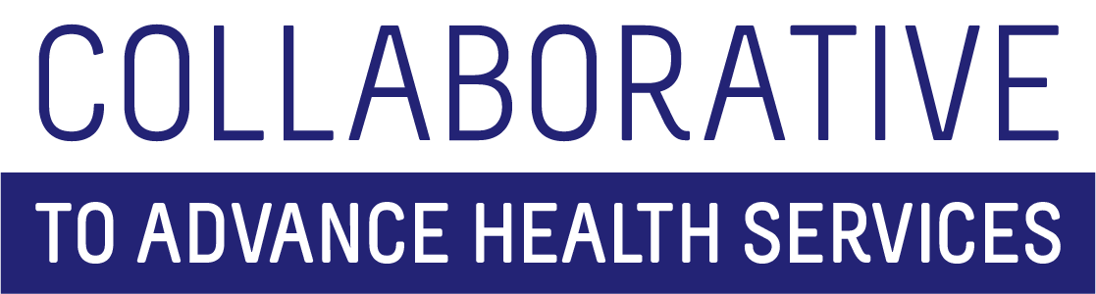

All Hands Meeting
May 25, 2021
Agenda

- 2:00-2:20 Welcome, Agenda Review (Jacki)
- 2:20-2:30 Collaborative Return to Campus Update (Kelly)
  - Revised floor plan
  - Updated SOPs (5/11)
  - Summer FriYAYS – begins June 4; ends Sep 3rd
- 2:30-3:00 Fiscal Outlook
  - Pre-award efforts immediately upcoming (Jacki)
  - Recompete timeline for multiple grants 2021/22 (Laurie)
- 3:00-3:30 Relationship Building – why we do it (Holly)
- 3:30-3:45 CAHS Training Opportunities (Pat)
  - June SBIRT ToT #1: June 7 and 8 (9:00 am – 12:30 pm each day)
  - 508 Compliance Workshop: 8-10 staff per session; tentatively scheduling on Fridays in July
  - August (PATH ToT 8/26/21 – afternoon)
3:45-4:00: Discussion
Adjourn

