2021 Summer Training
Overall, how satisfied were you with the SBIRT Training of Trainers (ToT)?
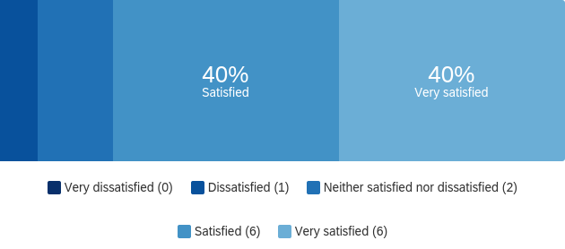

# | Field | Minimum | Maximum | Mean | Std Deviation | Variance | Count
1 | Overall, how satisfied were you with the SBIRT Training of Trainers (ToT)? | 2.00 | 5.00 | 4.13 | 0.88 | 0.78 | 15

Overall, how satisfied were you with the PATH Training of Trainers (ToT)?
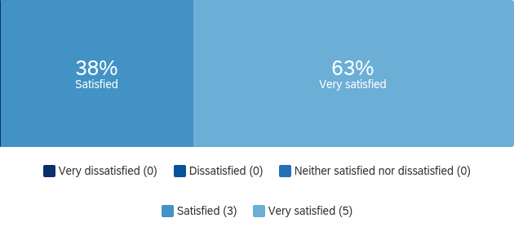

# | Field | Minimum | Maximum | Mean | Std Deviation | Variance | Count
1 | Overall, how satisfied were you with the PATH Training of Trainers (ToT)? | 4.00 | 5.00 | 4.63 | 0.48 | 0.23 | 8

Overall, how satisfied were you with the 508 Compliance training?
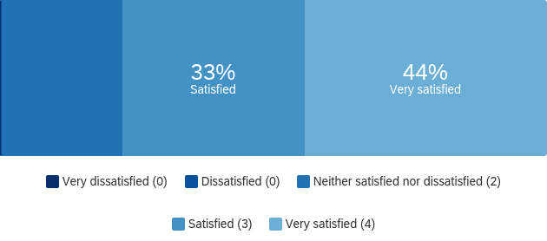

# | Field | Minimum | Maximum | Mean | Std Deviation | Variance | Count
1 | Overall, how satisfied were you with the 508 Compliance training? | 3.00 | 5.00 | 4.22 | 0.79 | 0.62 | 9

How would you rate the trainer who delivered the SBIRT ToT?
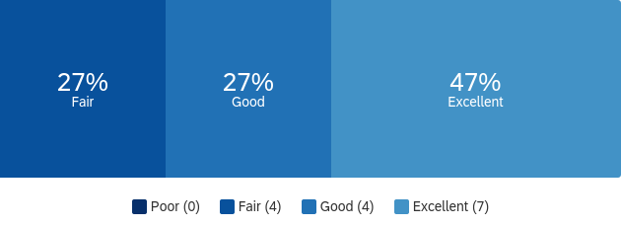

# | Field | Minimum | Maximum | Mean | Std Deviation | Variance | Count
1 | How would you rate the trainer who delivered the SBIRT ToT? | 2.00 | 4.00 | 3.20 | 0.83 | 0.69 | 15

How would you rate the trainer who delivered the PATH ToT?
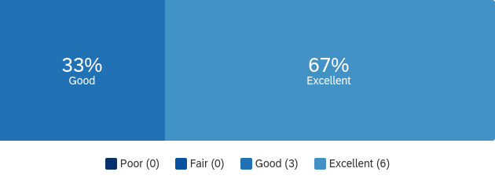

# | Field | Minimum | Maximum | Mean | Std Deviation | Variance | Count
1 | How would you rate the trainer who delivered the PATH ToT? | 3.00 | 4.00 | 3.67 | 0.47 | 0.22 | 9

How would you rate the trainer who delivered the 508 Compliance training?
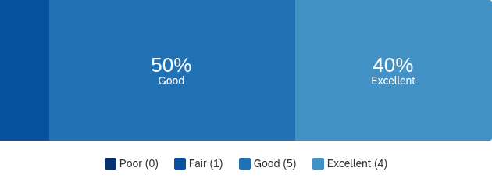

# | Field | Minimum | Maximum | Mean | Std Deviation | Variance | Count
1 | How would you rate the trainer who delivered the 508 Compliance training? | 2.00 | 4.00 | 3.30 | 0.64 | 0.41 | 10

After attending the SBIRT ToT, would you feel comfortable training others on its use?
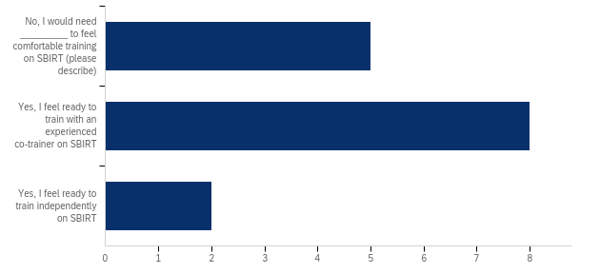

# | Field | Minimum | Maximum | Mean | Std Deviation | Variance | Count
1 | After attending the SBIRT ToT, would you feel comfortable training others on its use? - Selected Choice | 1.00 | 3.00 | 1.80 | 0.65 | 0.43 | 15

Q7_3_TEXT - No, I would need _________ to feel comfortable training on SBIRT (please de...
No, I would need _________ to feel comfortable training on SBIRT (please describe) - Text
a little more practice. I think the gap between learning and training is too great. Possibly supporting a lead trainer
additional training, especially on the Referral to Treatment aspect
additional training
more indepth knowledge about SBIRT. I know the basics and could probably do a training but since it is not an area of expertise for me, I do not feel super comfortable with the idea.

After attending the PATH ToT, would you feel comfortable training others on its use?
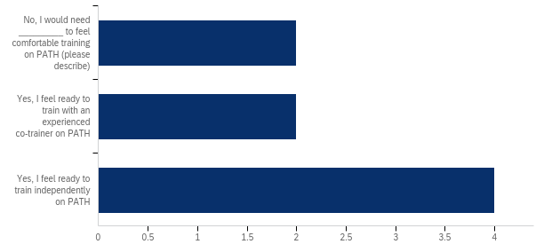

# | Field | Minimum | Maximum | Mean | Std Deviation | Variance | Count
1 | After attending the PATH ToT, would you feel comfortable training others on its use? - Selected Choice | 1.00 | 3.00 | 2.25 | 0.83 | 0.69 | 8

Q8_3_TEXT - No, I would need _________ to feel comfortable training on PATH (please des...
No, I would need _________ to feel comfortable training on PATH (please describe) - Text
more practice with PATH questions
additional training. I had to leave early.

After attending the 508 Compliance training, would you feel comfortable reviewing materials for compliance?
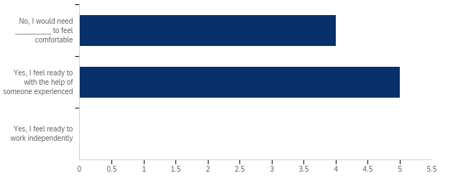

# | Field | Minimum | Maximum | Mean | Std Deviation | Variance | Count
1 | After attending the 508 Compliance training, would you feel comfortable reviewing materials for compliance? - Selected Choice | 1.00 | 2.00 | 1.56 | 0.50 | 0.25 | 9

Q9_3_TEXT - No, I would need _________ to feel comfortable training on 508 compliance (...
No, I would need _________ to feel comfortable training on 508 compliance (please describe) - Text
more practice
more training on the software.
more practice
another training

Please add any other comments or observations about any of the training offered this summer:

Please add any other comments or observations about any of the training offered this summer:
The SBIRT & PATH trainings I attended were very long. I don't think we need to dedicate that many hours.
The 508 compliance training used office software that unfortunately was outdated on my computer. I did not have access to the tools so was unable to practice alongside everyone else. I wish I had been told ahead of time to ensure I was using certain software versions. With the TOTs, I feel like they were both more introductions to the subject than a training that prepared me to train.
I was in the first session of the SBIRT Tot. I think it would have been better if there was a better management of time and clearer directions when going into breakout rooms. While I understand that in-person trainings have been postponed due to covid, I think I would benefit more from an in person training.
Really appreciated the training!

What other training or professional development activities would you like to see offered in the future?

What other training or professional development activities would you like to see offered in the future?
Project Management
Unsure at this point
I think another PATH ToT would be great.
Grant writing and how to be a successful PI

