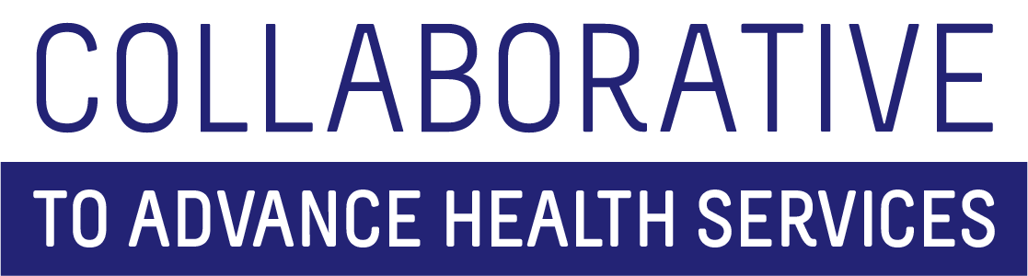
All Hands Meeting
March 11, 2022
Agenda

Full Team -- 9:00-10:30 – [Zoom Link to come]
- Ice Breaker and New Team Member Introductions
- Refresher on Clifton Strengths
  - Overview of program from Sherrie
  - Why we do this for the Collaborative
- Upcoming Professional Development Activities
  - Fiscal Orientation/Training
  - Health Sciences Library Tour
  - HealtheKnowledge
  - University-level training opportunities
- SoNHS Values – Located on Box https://umkc.app.box.com/folder/157623291243
- SOPs
  - University policies come first
  - SOPs are additional layer of operating policies for CAHS team
  - Potential funding opportunities process – grants, contracts, sub-contracts, etc.
Break – 10:30 – 10:45
Breakout Sessions – 10:45 – 11:45
Breakout 1: Leadership/Supervisors – [Zoom Link to come]
- Becoming an Institute or Center at UMKC
Break out 2: Lightening Talks – [Zoom Link to come]
- Carissa and Greg – what is happening around forming the communications team – 10 minutes or less
- Stephanie and Brizhana – what happened at the recent fiscal retreat – 10 minutes or less
- Katherine and Shelby – what does it takes to put together the CTCFP virtual conference – 10 minutes or less
- Van and Steph – what it is like to work on large needs assessment projects with UM PH Dept. – 10 minutes or less
- Open discussion for whole group: Sharing, Learning and Networking
Reconvene in Large Group – 11:45 – 12:00 – [Add Zoom Link]
- Thoughts, Questions and Epiphanies
Adjourn – 12:00

