Steps to take when submitting a consulting agreement request to ZenDesk:
- Sign into ZenDesk before submitting a ticket (this is so you can go back in and track the status of your ticket)
- Submit W9, SOW, and contract request form to ZenDesk at the same time
- Agreement is created by fiscal staff and returned to the project manager who submitted the ticket
- The project manager reviews the form for accuracy, then either send the agreement back to fiscal for revisions or to the consultant for review and signature
- Project manager receives the signed agreement from the consultant and returns the agreement via the SAME ZenDesk ticket
- Fiscal staff submits the agreement to the contracts portal or creates a requisition for a purchase order
- Once the agreement is fully executed and approved by all parties in the UMKC Contracts Department, a copy is returned to the project manager on the SAME ZenDesk ticket, and the project manager returns a copy to the consultant
- Ticket is closed.
If you are having trouble navigating or finding the original ZenDesk Ticket, reach out to fiscal staff for assistance, we are here to help!
Guidelines on drafting a Scope of Work (SOW)
Submit the SOW as a Word or PDF document with the W9 and contract request form. Do not submit an original email or proposal from a consultant that contains their tasks/responsibilities. The email or proposal needs to be edited into a SOW.
Some grants have project managers completing a consulting agreement or appearance agreement on their own and sending it directly to the consultant for signature. Please discontinue this process. The Contracts Office at the UM System level goes through legal processes and changes contract forms frequently, which sometimes causes verbiage and legal content to change. Submitting a request through ZenDesk ensures that we are using the most up-to-date forms and that we are in compliance with university policy. If you wish to fill them out for us, you will need to take contract training with the UM System.
SOWs should include the following (at a minimum)
- Period of performance – must not precede/exceed grant year (doesn’t necessarily have to be on SOW if info is already on the contract request form)
- Hourly rate (doesn’t necessarily have to be on SOW if info is already on the contract request form)
- Up to how many hours (doesn’t necessarily have to be on SOW if info is already on the contract request form)
- Overview of responsibilities
- Travel (mileage, luggage, ground transportation, lodging, per diem, etc.)
- Travel day rate
- Any other circumstances required

Examples of past SOWs:
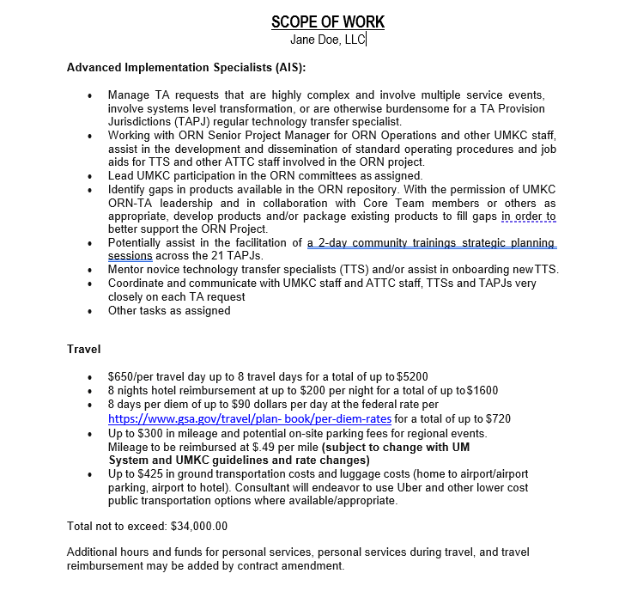

SOW for Sally Smith
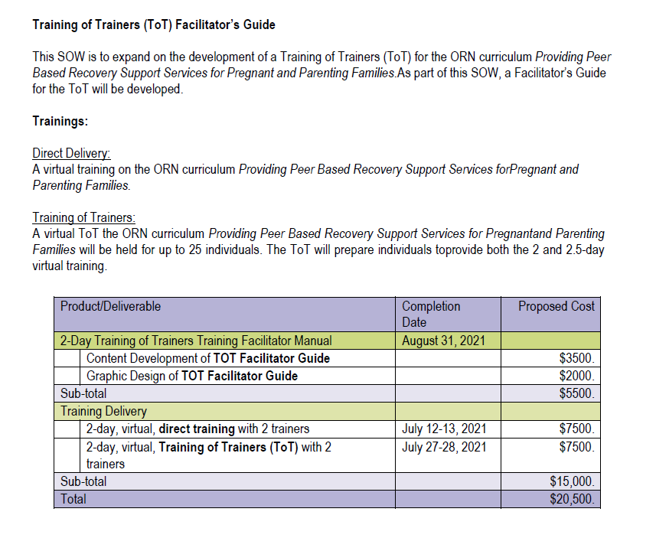

SOW for John Doe LLC
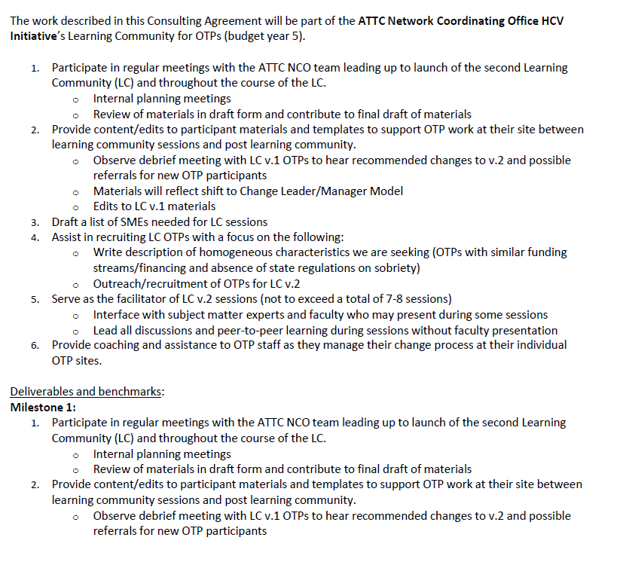

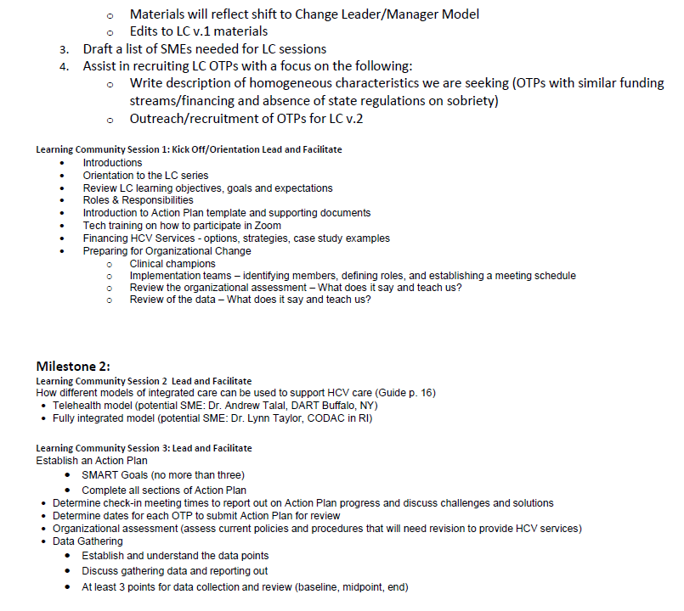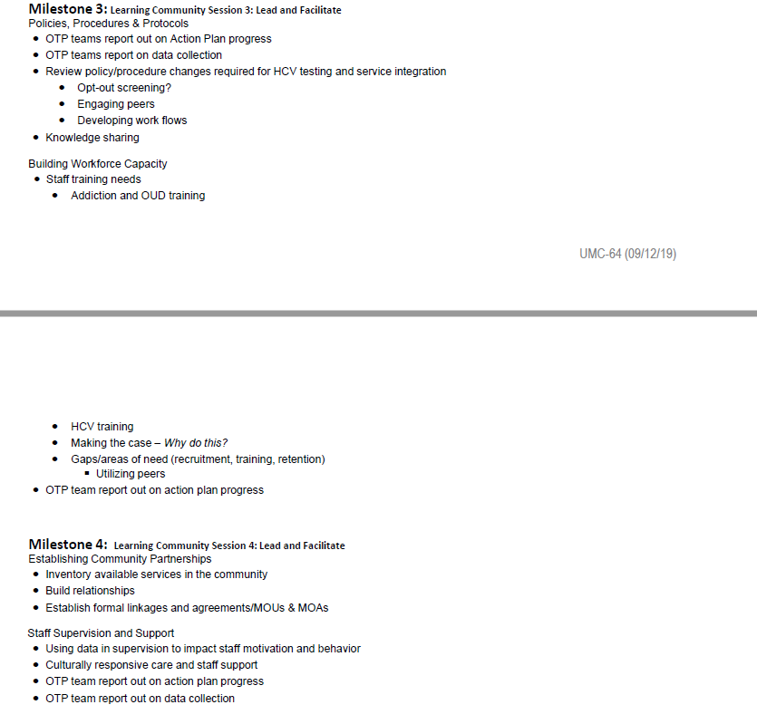
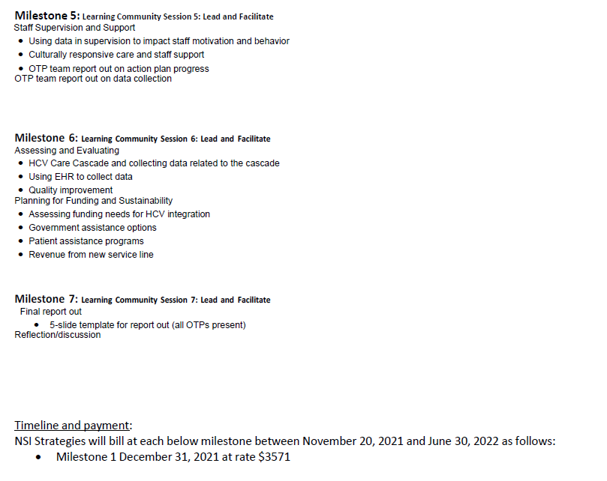
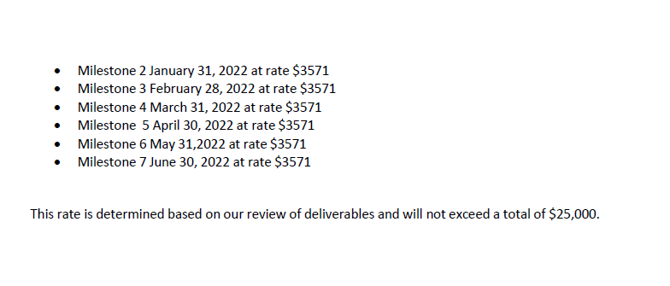

SOW for Dr. Sally Smith
Trauma informed care for clinicians job aid
Total contract not to exceed $ 750.00
Scope of work for Dr. Sally Smith

Deliverables |  | Description | Hrs. | Cost | Timeline
1 | Review draft product | Critique of 6-page clinician job aid for (working title) Trauma Informed Care in the Exam Room | 4 | $150 X 4 hrs ($600) | On or about July 11 to July 18, 2022 (7-day turnaround)
2 | Provide recommendations (with references) | Provide content (with references) and format (for clarity and visual appeal) recommendations for draft product | 1 | $150 | No later than July 20, 2022
 |  | Total Contract |  | $750.00

