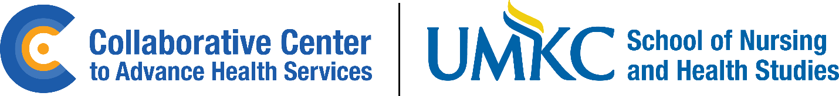

All Hands Meeting
September 29, 2023
Agenda
9:00-9:05 Welcome/open meeting (Lisa)
9:05-9:25 Ice Breaker – Family Feud (Kristen Zucht)
9:25-9:35 Acknowledgment of recent successes (Holly)
  - Congrats to CTC SRH on a successful 2023 NRHC
  - Recent conference submissions and acceptances
  - Adam named AHSR Early Career Investigator
9:35-9:45 Staffing Transitions (Maxine)
  - CTC SRH transition
  - New CCAHS staff
  - Changes in staff roles (PTTC)
9:45-10:00 Collaborative Center to Advance Health Services Update (Adam)

  - Logo and other brand elements
  - Web page on UMKC website (URL coming soon)
  - We are working on a 9-month plan for launch of the Center (without a budget); we will share more information on Center Director position announcement and official launch in the next six months
10:00-10:15 Syndemic Solutions Summit update (Kristin)
- Regional Guided Discussions and Roundtables
- Possible development of a Coalition of collaborators
- Next Summit will be Spring 2025

10:15-10:30 Bringing back the Collaborative Connection (Kelly)
  - Example to share (July 29, 2022 issue)
  - We need two volunteers for one year and to develop a process to transition to new volunteers
    - One person to curate content and get it approved with ET
    - One person to copy edit and design/layout using Canva
    - Decide on frequency (monthly, bi-monthly)

10:30-10:35 Addiction Health Services Research Conference 2025 – in Kansas City! (Laurie)
10:35-10:45 Announcements (Jacki)
- CCAHS vision, mission, and values
- Remote work acknowledgement form update
- Fiscal reminders (link to fiscal web page)
- Next all-hands meeting is the holiday party
- ORS email about Federal Government shut-down

