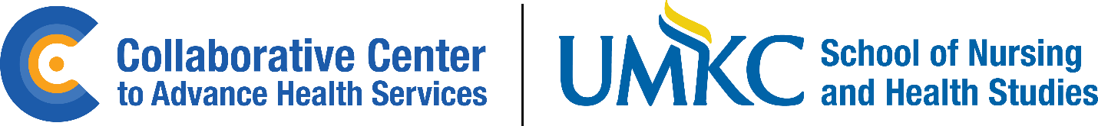

All Hands Meeting
April 5, 2024
Agenda
9:00-9:05 Welcome/Open Meeting (Kristin/Katey)
9:05-9:15 Ice Breaker (Jenny and Steph)
9:15-9:30 Center Update (Kristin/Kelly)
    - What does it mean to be a Center in the University
    - Long term Interim Center Director search
    - Funding – is dictated by the University policies
    - Progress updates – communications, job description for Interim Center, Director logo, center website, etc.
    - Standing agenda item
9:30-9:45 Syndemic Solutions Update (Adam)
- Conference 2025
- Other updates – listening sessions
- Coalition development
- Publications update – article, presentation, and poster
9:45-10:00 Upcoming Grants Up for Recompete (Laurie)
10:00-10:30 Clifton Strengths Update and Resources (Andrea)
10:30-10:45 CCAHS Shout outs (All)
- Post in the chat or unmute and tell the team any successes
10:45-10:55 Action Items (Holly)
10:55-11:00 Closing (Kristin/Katey)

