Online/Phone Resources for Recovery Support, Parenting, and COVID-19

Recovery
AA
https://aaboston.org/ has a list of in-person meetings that are still happening in Boston
Area
https://westernmassaa.org/aa-meeting-schedules scroll down and there is information
on the impact of Covid-19 on meetings, as well as a link to online meetings
http://aa-intergroup.org/ allows you to search for online AA meetings
https://www.onlinegroupaa.org/

AA en Espanol https://aa-intergroup.org/languages/index_es.html

Pause a while
Hosting free conference calls for AA meetings at 2pm every day
  - Dial in number: 425-436-6360
  - Access Code: 422932

A Virtual Awakening
Closed online AA meeting for women, trans, and non-binary people
Recovery literature, speakers, open discussion
Sun, Mon, Wed, Fri at 8:30pm EST, Thurs 1:00pm EST
- https://zoom.us/j/4822208285

NA
https://nerna.org/ has lists of meetings in New England that are currently closed and available online meetings
- Narcotics Anonymous World Services (NA): has a statement on the Coronavirus, including a link to find MA intergroup phone numbers https://www.na.org/admin/include/spaw2/uploads/pdf/Coronavirus_web_message_12Mar.pdf
- Phone meetings: www.nabyphone.com
- Online meetings: https://virtual-na.org/
https://virtual-na.org/meetings/ allows you to search for meetings in multiple languages

www.naspeaker.com Streaming 24-7 Free NA Speakers
https://www.neveraloneclub.org/ has online NA meetings (NOT affiliated with NA World Service)

Other 12-Step Meetings
Al-Anon and Alateen
https://ma-al-anon-alateen.org/ - there is an announcement about Covid-19
https://al-anon.org/al-anon-meetings/electronic-meetings/
https://docs.google.com/spreadsheets/d/1JplQ5VEcmPRtBGwLCPRBRQ_VoSecquSyE0JsAQLTkA0/edit#gid=1068214983 list of which meetings have been cancelled or are still running

Cocaine Anonymous offers online support and services
https://www.ca-online.org

Marijuana Anonymous
http://marijuana-anonymous.org/find-a-meeting/
Nicotine Anonymous
www.nicotine-anonymous.org - has many online and telephone meetings, with a list available on the website

Recovery Speakers: Listen to recovery speakers from many different 12 step groups
www.recoveryspeakers.com

Sober Recovery provides an online forum for those in recovery and their friends and family https://www.soberrecovery.com/forum

Embark Recovery: Daily 12pm & 6 pm in English and 12:30 and 5:30 in Spanish)
https://www.embarkreco.com/events

Herren Project: Variety of meetings, including Women’s Meeting Tuesdays at 7:30PM
https://herrenproject.org/recovery-meeting/
In the Rooms: online meeting at 9am, 12pm, 3pm, 6pm, 9pm. These are “all recovery” meetings and any pathway or programs are welcome.
https://www.intherooms.com/home/category/community-and-meetings/

LifeRing Secular Recovery is an organization of people who share practical experiences and sobriety support, and embraces what works for individual. On line meetings offered.

https://www.lifering.org/online-meetings

Lion Rock Recovery: Variety of support groups every day of the week
https://www.lionrockrecovery.com/online-aa-meetings-and-support-groups

Phoenix Gym offers a range of FREE virtual exercise classes (meditation, yoga, CrossFit, etc. for people in recovery. Every 2 hours from 7 am - 9pm
https://thephoenix.org/virtual/

Recovery Dharma
https://recoverydharma.online/ has meetings using Buddhist practice
Reddit Recovery offers a virtual hang out and support during recovery
https://www.reddit.com/r/REDDITORSI NRECOVERY/

Refuge Recovery provides online and virtual support
http://bit.ly/refugerecovery1

SMART Recovery
https://www.smartrecovery.org/community/ has a wide variety of online resources
http://www.smartne.org/meetings.html: has a listing of meetings but also a link for online meetings

SoberCity offers an online support and recovery community
https://www.soberocity.com/

Sobergrid offers an online platform to help anyone get sober and stay sober
https://www.sobergrid.com/

Soberistas provides a women-only international online recovery community
https://soberistas.com/

Sober Mommies: online support group for moms in recovery
https://sobermommies.com/groups/online-support/

WEconnect and Unity Recovery - 4 times daily 7 days a week (9am,12pm,3pm,9pm EST)
Join directly from computer or smart phone - unityrecovery.zoom.us/my/allrecovery
- unityrecovery.zoom.us/my/allrecovery

Women for Sobriety –https://womenforsobriety.org/ (website) https://wfsonline.org/ (online meetings)
Helps women gain hope and encouragement with other women in similar circumstances. Offering tools to a healthier lifestyle.

Support for Families with a loved one with SUD
Smart Recovery Family
Smartrecovery.org/family

Learn to Cope
https://www.learn2cope.org/

Al-anon
Al-anon.org/electronic-meetings

Recovery Apps (download to your smartphone via app store/google play/website)
- Sober Grid - App Store
- Celebrate Recovery - App Store
- Smart Recovery - www.smartrecovery.org
  - Connections smartphone app to support recovery
https://www.addictionpolicy.org/connections-app

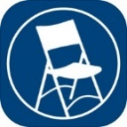 MEETING GUIDE is a free mobile app focused on helping people find A.A. meetings and resources near them. Also included are DAILY REFLECTIONS – a selection of reflections by and for A.A. members.
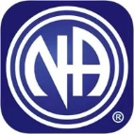 NA MEETING SEARCH is a free mobile app developed to help find an NA meeting. It can use your current location to display the meetings nearest you. Daily JUST FOR TODAY meditations are also bundled in this app. http://www.nabyphone.com/

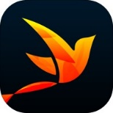 RECOVERY PATH is a free mobile app is designed to allow people to navigate their own path to sustained recovery, share progress with others, and receive support.

Online Resources to Support Your Recovery
Scan the QR code below to go directly to the type of support you are looking for.
- Online AA Meetings  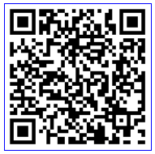 | - Recovery Dharma Online Meetings  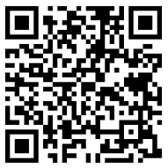 | - In the Rooms Online Support  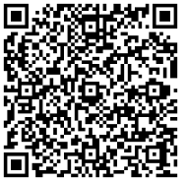
- Al-Anon Electronic Meeting List  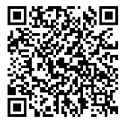 | - Online Group AA Meetings  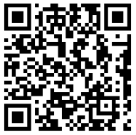 | - Substance Abuse and Mental Health Services Website  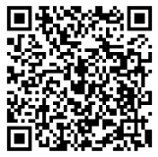
- Virtual Narcotics Anonymous Meetings  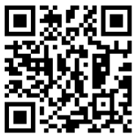 | - Smart Recovery Online  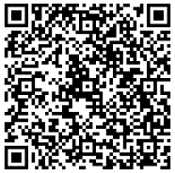 | - Never Alone Club – 24 Hour Chat and Support  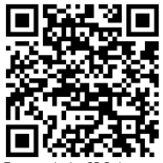
- Narcotics Anonymous by Phone  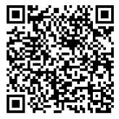 | - Marijuana Anonymous Online Meetings  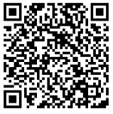 | - Connections App – tools to support early recovery  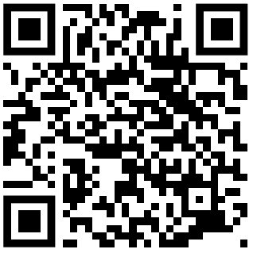
- The Herren Project – Recovery Meetings  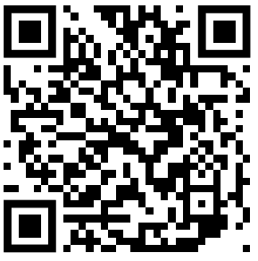 | - AA speaker tape and 12 steps – iPhone App  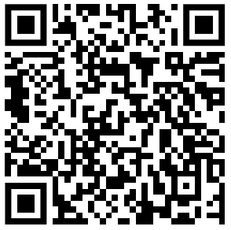 | - Smokefree – Tools and Support to Quit Smoking  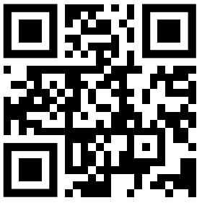

Facebook Recovery Groups (logon to Facebook, search group, ask to join)
- CLEAN AND SOBER - Addiction Recovery Support Group
- Daily Reflections AA
- Methadone & Buprenorphine Discussion and support
- MIPSA-Methadone Information & Patient Support Network
- Mommy Group
- Recovery Soldiers
- Send it! (Recovery Network)
- Sober Mommies
- Voices To End Addiction & Inspire Recovery
- Women in AA

Parenting/Families
Children’s Trust has resources about COVID-19, as well as links to online parent groups and play groups
https://onetoughjob.org/

Hello It’s Me is a Facebook group for families that are pregnant and close to delivery or home with a newborn during COVID-19
https://www.facebook.com/groups/204741563956171/

Parenting Journey is creating an emergency fund and families can request a stipend (it’s not required that you have attended any PJ groups, any families in need of assistance are welcome to apply) for those impacted financially by the COVID-19 crisis.
https://parentingjourney.org/it-takes-a-village-emergency-fund/

Parents Helping Parents
Parental Stress Line (available 24/7): 1-800-632-8188
Online Support Groups occurring every day but schedule changes week to week
Check the website for schedule: https://www.parentshelpingparents.org/
- Click this link to join the meeting by computer or smartphone: https://zoom.us/j/6607380697
- No Computer, Dial in by phone: 1-646-558-8656 then input the meeting id 6607380697#

National Parent Helpline
1-855-4APARENT (1-855-427-2736)

Sober Mommies: online support group for moms in recovery
- https://sobermommies.com/groups/online-support/

COVID-19 Resources

COVID-19 FAQs from mass.gov
https://www.mass.gov/info-details/frequently-asked-questions-about-covid-19

CDC Information about preparing your family
https://www.cdc.gov/coronavirus/2019-ncov/prepare/index.html

Talking to children about Covid-19 (available in multiple languages)
Talking to Children About COVID-19 (Coronavirus): A Parent Resource
Supporting Kids During the COVID-19 Crisis

Just for Kids: A Comic Exploring the New Coronavirus
http://www.capradio.org/articles/2020/03/07/just-for-kids-a-comic-exploring-the-new-coronavirus/

Time to come in, Bear (a short video for young children about physical distancing)
https://www.youtube.com/watch?v=DA_SsZFYw0w&fbclid=IwAR38adgHsKi7U0LYE33HFhVXP4rJPDcS-6zY_JytF_1JwylWll7IbK_FM7Y

Coping/Managing Stress:
Mental Health and Coping During COVID-19

How to Avoid Passing Anxiety on to Your Kids
https://childmind.org/article/how-to-avoid-passing-anxiety-on-to-your-kids/?utm_source=newsletter&utm_medium=email&utm_content=%20Parents%20Guide%20to%20Problem%20Behavior&utm_campaign=Weekly-03-16-20

National Child Traumatic Stress Network resource on helping parents talk to children about COVID-19
https://www.nctsn.org/sites/default/files/resources/fact-sheet/outbreak_factsheet_1.pdf

link to same in multiple languages:
https://www.nctsn.org/resources/parent-caregiver-guide-to-helping-families-cope-with-the-coronavirus-disease-2019

Link for small children from ZERO TO THREE
https://www.zerotothree.org/resources/3210-tips-for-families-talking-about-the-coronavirus

Link Boston + MA COVID19 Resources
https://docs.google.com/document/d/1-x6vOZKVsla5H363mtdgcyivvLmcx7-f2s6l-O_ba8A/mobilebasic

Other Resources

7cups offers free emotional support. No matter what you are going through you will be heard and cared for. 24/7 chat.
https://www.7cups.com/online-therapy/

Local Crisis Hotlines
- Northampton CSO 413-586-5555
- Greenfield CSO 413-774-5411
- Holyoke BHN 413-532-8016
- Springfield BHN 413-733-6661
National Domestic Violence Hotline offers help to people experiencing violence in their home during COVID-19 restrictions. There is a hotline, texting service, and webchat service. https://www.thehotline.org/2020/03/13/staying-safe-during-covid-19/
National Suicide Prevention Lifeline
- 800-273-8255

Project Bread’s FoodSource Hotline provides up-to-date information– in multiple languages – about what is happening in school districts and what resources are available, such as SNAP application assistance, and referrals to open community resources.
The FoodSource Hotline can be reached at 1-800-645-8333 or
by chat at Gettingsnap.org

Samaritans: Helpline remains open 24/7 for calls and texts at
- 877-870-4673

SAMHSA National Helpline
- 800-662-4357
- https://www.samhsa.gov/find-help/national-helpline

