“Fostering Dialogue: Exploring the Intersection between Prevention and Harm Reduction”

This project is a collaboration between the Prevention Technology Transfer Center Network, Opioid Response Network, National Harm Reduction Technical Assistance Center, CADCA, and the Partnership to End Addiction. The purpose of this project is to increase communication and understanding between professionals who work in primary prevention and harm reduction. To achieve this, we will facilitate in-person conversations between professionals in both fields, so that we can document and study their dynamics in order to design tools which will be made available to communities interested in conversation and collaboration between their prevention and harm reduction initiatives.

There are misconceptions about harm reduction, such as it enables risky behavior, it exchanges one addiction for another, or that it opposes long-term recovery. Creating an environment for deep dialogue is essential to work through these types of misconceptions. We believe that it takes seeing things up close and personal to understand and appreciate the full scope of an organization’s work. Ultimately, primary prevention and harm reduction have the same end goal of promoting health, well-being, and saving lives. By facilitating in-person dialogue, we will enhance education in harm reduction, gain new perspectives, and improve communication between professionals in the field.

To achieve this goal, we are coordinating site visit exchanges between prevention and harm reduction organizations.

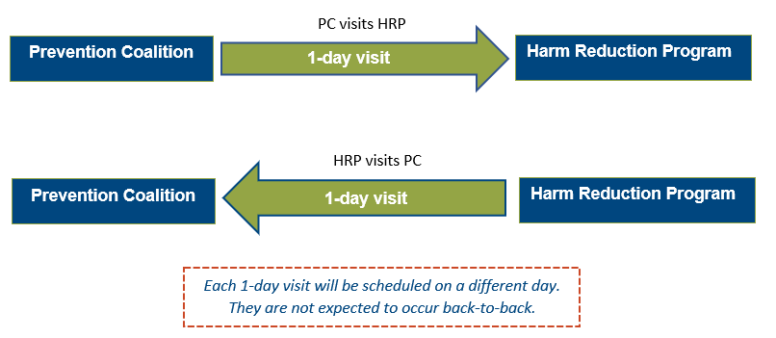

During your visit to the harm reduction program, you will observe and study how the site is serving its community and gain valuable insight that will enhance your knowledge and skills in both substance use prevention and harm reduction. Vice versa, when the harm reduction program visits your agency, they will observe and study your work.

Each site visit will last one day, plus variable travel time the days before and after. We anticipate a full-work day (approx. 6-8 hours). All visits will be scheduled for before September 8, 2023.

We will cover travel expenses including airfare, ground transportation, lodging, and a daily per diem (rates vary depending on geographic location, as defined by the federal government). A member of our team will work with you and your colleagues to make all travel arrangements. Once both 1-day visits have been completed (approx. 4-8 weeks after), we kindly ask for your participation in a follow-up conversation held over Zoom or similar platform, which will be audio recorded. The aim of this recorded conversation is to explore the insights gained during the in-person interactions and utilize the collective comments to develop tools which will be made available to communities interested in sparking dialogue.
If you are interested in participating or learning more, please contact the project director Susan Garrett at garrettsv@umkc.edu.
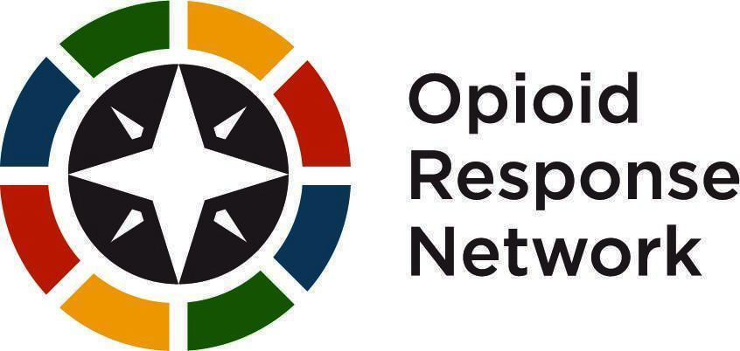
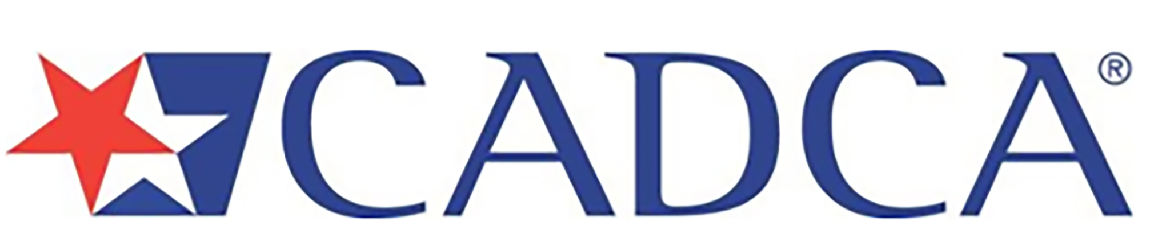
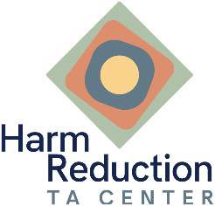
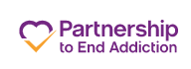
Sincerely,

