In the next few days, you will receive an email from the TTC requesting you to join the mailing list ttc.simplelists.com. It will look like this:

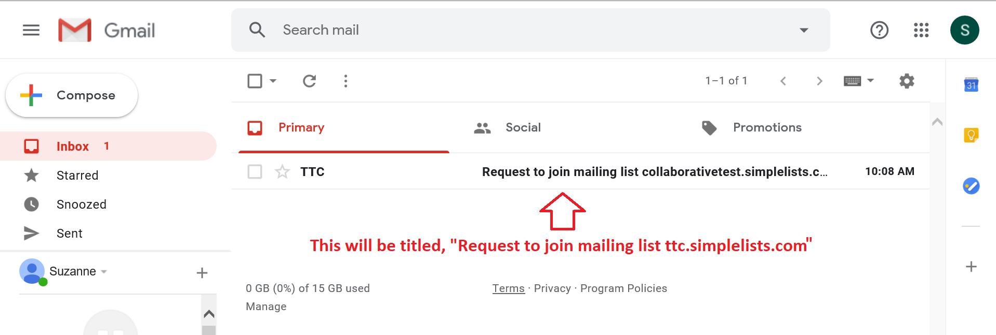
Open the email and you will see this:
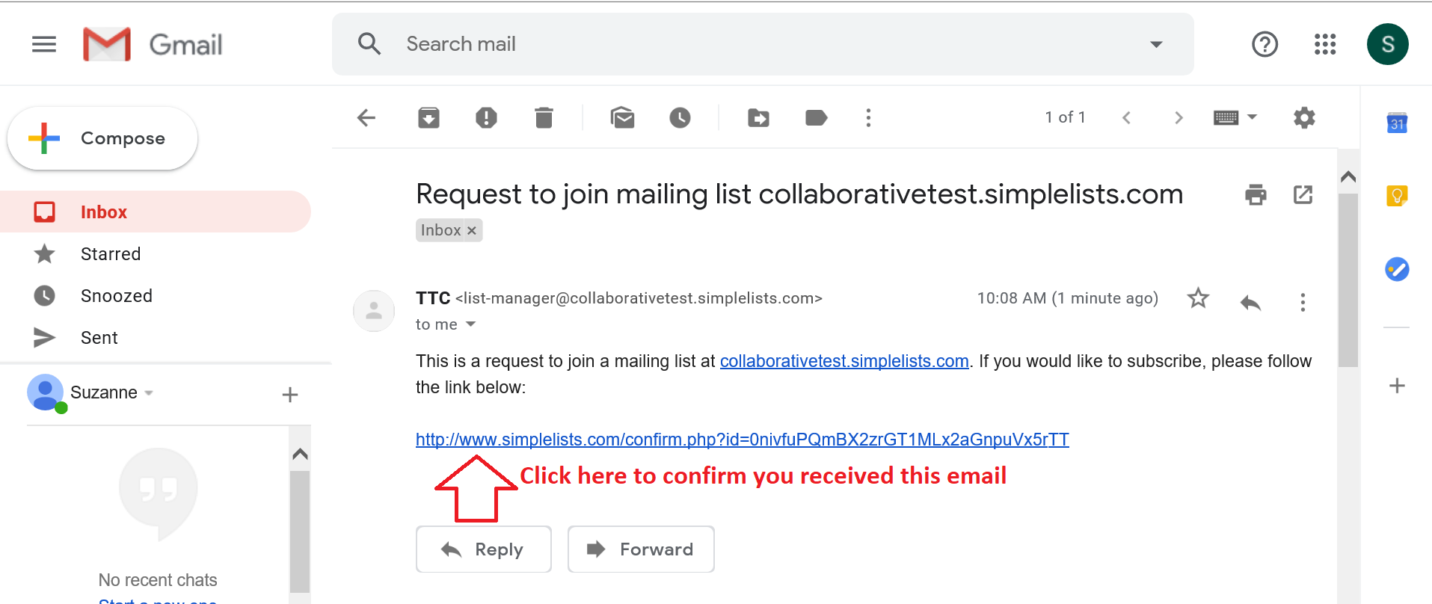
Click on the confirmation link. Your web browser will open and you will see the following:
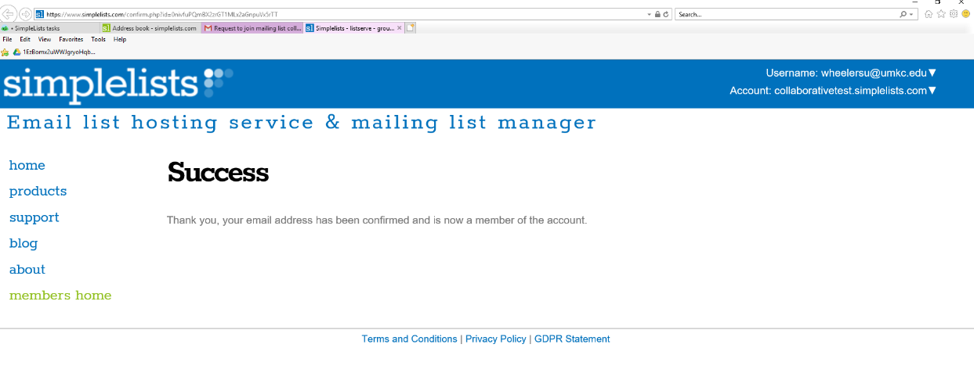
Congratulations! You are now confirmed as a member of the email list for the TTCs. We will make sure that you are added to all of the subordinate listservs which you are currently enrolled.

