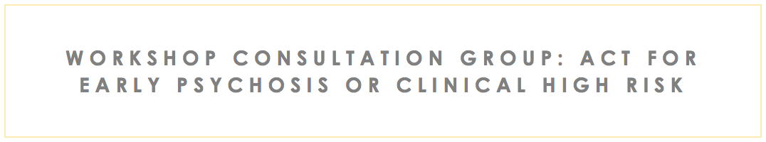

## Expand your skills and Help your clients in their recovery!



**What is Included?**

* 4-hour workshop split into two sessions
* Participants will be given 3 months of access to recordings of the sessions and a resources folder with materials to use in clinical practice.



There is a growing evidence base for the efficacy mindfulness-based treatments (Including Acceptance and Commitment Therapy) for youth experiencing psychosis or signs of clinical high risk. This workshop is for clinicians working with youth with psychosis or at clinical high risk who are hoping to increase skills in using ACT for psychosis in their work.

Participants will receive resources for asynchronous learning and will have opportunities to share de-identified information about their ongoing work with clients during the live video-sessions.



Learning Objectives:

1. Identify the basic tenets of mindfulness-based treatments (including ACT) for youth experiencing early psychosis or signs of clinical high risk.
2. Discuss unique aspects and challenges of providing culturally informed mindfulness and acceptance-based treatments for individuals experiencing early psychosis or clinical high risk for psychosis.
3. Apply skills learned to develop an ACT based clinical formulation for clients currently in their practice.
4. Identify resources and psychoeducational materials useful for clinical practice.
5. Determine which interventions to use for clients based on their Acceptance and Commitment Therapy clinical formulation.



**Registration Information:**

**Two-part virtual workshop:**

**Tues Aug 9 3-5 PM EST (1-3 PM MT)**

* Introduction to ACT and its application to treatment of early psychosis

**Tues Sept 13 3-5 PM EST (1-3 PM MT)**

* ACT-based clinical formulation and case discussion

**Cost:**

**$1700**

***Check payable to:***

**“BIDMC Continuing Education Program”**

**Attn: Sandi Leitao**

**330 Brookline Avenue**

**Rabb 205c**

**Boston, MA 02215**

**Note: “Friedman-Yakoobian ACT Workshop” in the memo line.**

**About Dr. Friedman-Yakoobian**

Dr. Friedman-Yakoobian has more than 20 years of experience treating youth and families impacted by early psychosis or clinical high risk. Dr Friedman-Yakoobian is the clinical director of the CEDAR clinic, a coordinated specialty clinic for youth at clinical high risk for psychosis. Also, she has conducted extensive research on the development of effective treatments for youth and families, and is an Assistant Professor in psychiatry at Harvard Medical School, where she has supervised dozens of clinicians in training to learn ACT and CBT.